Urban Classification from Combined LIDAR/RGB Data

|  |  |  |
| --- | --- | --- |
| M. Elhabiby | H. Elhifnawy | N. El-Sheimy |
| Department of Geomatics Engineering, University of Calgary, 2500 University Dr. NW, Calgary, Alberta, Canada, **T2N 1N4** | | |
| [mmelhabi@ucalgary.ca](mailto:mmelhabi@ucalgary.ca) | [heeeid@ucalgary.ca](mailto:heeeid@ucalgary.ca) | [elsheimy@ucalgary.ca](mailto:elsheimy@ucalgary.ca) |

**ABSTRACT**

Although RGB image provides a rich descriptive data for ground and non-ground objects, it is impossible to separate features sharing in texture properties. The main objective of this research paper is to investigate a feature classification technique using RGB/LIDAR data. Wavelet transform is used for detecting non-ground feature candidates from height LIDAR data. Otsu segmentation is used to detect vegetation and shadow candidates from RGB image. Building candidates are identified after removing vegetation areas from non-ground feature image. The remaining pixels in an image for urban area are considered as road candidates. The investigated technique is automated and efficient when using data from integrated sensors that provide all positional and semantic information as XYZIRGB for dense point clouds.

**KEYWORDS:** RGB, LIDAR, Wavelet Transform, Vegetation Detection, Building Candidates

# Introduction

Feature classification is the base for many civil and military applications, such as city development, forest monitoring, and road network extensions. Feature classification sometimes has obstructions depending on data availability. For example, feature classification from RGB image is straight forward when detecting texture properties for different features [Bong et al., 2009], but in the case of existing different features sharing texture properties, the problem will be more complicated. Feature classification from another data acquisition sensor with spatial information similar to LIght Detection And Ranging (LIDAR) data has a problem when there are different features sharing the same height information, such as trees and buildings in urban areas. On one hand, features can be detected and recognized visually from RGB image because of the dense semantic information for all objects [Ghanma, 2006]. On the other hand LIDAR system is considered one of the most preferable positional data collecting system because of its high rate data acquisition and providing positional information for each scanned point [Al-Durgham, 2007]. This research paper will use combined semantic and positional information for dense data points obtained by two methods.

The proposed feature classification technique of this combined data is based on efficient extraction process that can extract or separates specific features and/or object from a study area. This research paper is introducing feature extraction process for the classification and extraction of roads, vegetation areas, and buildings.

There are many researchers generally worked on feature extraction from RGB images (airborne digital or satellite images), such as Song and Shan [2008]. They investigated a building extraction technique from high resolution RGB image after transforming the input image to CIE L* a* b* color space, by applying active contour segmentation to detect building boundaries. This technique is succeeded in case of red rooftop buildings because of the high contrast between red colour and the background. Sirmacek and Unsalan [2008], also detected building roofs based on calculating color invariant image from red color and green color channels. Bong et al. [2009] investigated a color channel ranges that represent a road texture property after transforming RGB image from RGB color space to $YCbCr$ and $HSV$ color spaces. This technique is efficient for high resolution satellite images, but with clearly differentiable and distinguishable semantic information between buildings and roads as red rooftop buildings to avoid extracting building pixels as road candidates. Shorter and Kasparis [2009] produced an automatic technique for building extraction from RGB images produced from digital camera. Watershed segmentation technique is applied on a raw RGB image followed by calculating solidity properties for all segmented regions to investigate building and non-building candidates. This technique succeeded in the detection of vegetation, shadows and building areas from RGB image, but with the several conditions and constrains applied by Bong et al. [2009].

Feature extraction research was also done on LIDAR data utilizing the significant height information for different features. Nardinocchi et al. [2001] used last return of LIDAR pulses to generate LIDAR image with 1m x 1m grid. Roof plane segmentation is performed using RANdom SAmple Consensus (RANSAC) algorithm that search for data fitting different planes and used for extracting contour lines. Kim et al. [2007] investigated a new approach for LIDAR data segmentation based on three main requirements, neighbourhood definition, deriving attributes for neighbourhood points, and clustering neighbourhood points with similar attributes. Adaptive cylinder method is used for detecting neighbourhood points that located in the same surface. Zeng [2008] filtered LIDAR point clouds using planar filtering filter to extract building surfaces using specific, height, length and delineation thresholds.

The previous mentioned techniques concentrated on extracting features with regular boundaries, continuous distributed point clouds, and/or uniformly sloped surfaces. These are not suitable for features with irregular boundaries, such as trees, poles, and structures with circular or ellipsoidal surfaces. This research paper will focus on the determination of the feature sudden height change with wavelet localization property aiming manly to separate the buildings from the other features, before applying Statistical filtering extraction on the RGB image without the buildings features. The wavelet previous research work was very specific and cannot be generalized, Vu and Tokunaga [2002] produced a clustering technique based on wavelet smoothing LIDAR image for different successive scales. The buildings points are extracted by masking the smoothed image to the original LIDAR image. These points are used to reconstruct 3D building models for the study area. They extended their research [2004] to produce a new clustering technique based on wavelet analysis that is called Airborne Laser Scanner Wavelet (ALSwave) for LIDAR data. This research used a combination between wavelet transform and fuzzy edge pixels to detect object points and bare earth points to generate DTM and DSM for the study area. Wang and Hsu [2006] detected building boundaries using spatial edge detection technique and analysed edge image using wavelet transform. The edges are detected after applying Canny edge detection technique. Falkowski et al. [2006] succeeded in extracting specific type of trees, conifer tree, from LIDAR data after generating a two-meter DEM and Canopy height Model (CHM) using natural neighbour through ArcGIS software. Wavelet analysis is executed using 2-D Mexican Hat wavelet function. Mexican Hat wavelet function is suitable for this specific tree type since its shape is similar to the conifer tree, which doesn’t require a prior knowledge about tree height or crown diameter, but the problem it is not suitable for all other tree types.

This research paper will introduce an automatic feature extraction technique that will use complementary information from LIDAR and RGB for urban areas based on combined filtering statistical wavelet multiresolution analysis using the power of wavelets to detect the sudden height change of buildings from LIDAR data and aiding this result to feature extraction statistical filtering algorithm from the corresponding RGB data.

# algorithm and Methodologies

The proposed algorithm shown at Figure 1 is applied on a registered set of LIDAR and RGB data. First, the wavelet transform is used for detecting non-ground feature edges from LIDAR data. The corresponding RGB image pixels, for the buildings removed from wavelet step separation, are removed. Second, the Ostu Segmentation is used for the separation of Vegetation and shadow. Third, color transformation is applied in two different color invariant domains to separate the sandy areas. The combination and application of these techniques, in this order, will lead to the separation of the above mentioned information (buildings, vegetation, shadows, and sandy areas) and finally, the roads and highways will be left at the end, which leads to an efficient urban classification algorithm.

Figure : Urban Area Classification Algorithm

## Two Dimensional Wavelet Analysis

When a variable $x$ and its values $f\left(x\right)$ are all finite, and discrete quantities, the wavelet function is discreditized into grid with dimensions ($λ_{o}^{m}, nt_{o}$), where $m$ is the scale parameter and $n$ is the dilation parameter. This grid is not regular and it is changing related to the scale and level of decomposition. Equation shows the mathematical model of Discrete Wavelet Transform (DWT) [Keller, 2004].

|  |  |
| --- | --- |
|  | () |

where: = wavelet function, $λ_{o}$ = scale, and $t_{o}$ = dilation

The wavelet analysis divides the signal into two main parts, low frequency part that is called approximation and high frequency part that is called detail, the approximation part is corresponding to the scaling function analysis and the detail part is the result of using wavelet function analysis. Equation shows the analysis step for the computation of the DWT coefficients (approximation and details) [Gonzalez et al., 2004].

|  |  |
| --- | --- |
| $$W_{φ}\left(m_{o},n\right)= \frac{1}{\sqrt{M}}\sum_{l}{f(x)}φ_{m_{o},k}\left(x\right)$$ $$W_{ψ}\left(m,n\right)= \frac{1}{\sqrt{M}}\sum_{l}{f(x)}ψ_{m,n}\left(x\right)$$ | (2) |

where: $φ$ = scaling function, $l$ (variable) = 0,1,2,.......,M-1, M =Total number of sampling, $m$ (scaling) = 1, 2,3,.......,m, and $n$ (transition) = 0,1, 2,........, $2^{m}-1$

The image is two dimensional for each direction X and Y. There are two analysing functions $φ$ and $ψ$ in each direction. The two dimensional wavelet transform is introduced by applying tensor product between one dimensional wavelet transform that is applied to both the X and Y directions (Equation 3). This process tends to get four analysing wavelet functions; one approximation and three detail wavelet functions and the resulting coefficients are arranged in a matrix in three directions (horizontal, vertical, and diagonal). Finally for higher level of decomposition the image at each level is analyzed into one approximation and three detail wavelet coefficient sets (horizontal, vertical, and diagonal) and all are created from the approximation coefficient set of the previous wavelet level of decomposition.

|  |  |
| --- | --- |
| $φ\left(x,y\right) =φ\left(x\right)φ(y)$ | (3) |
|  |
|  |
|  |

|  |  |  |
| --- | --- | --- |
| where: | $$φ\left(x,y\right)$$ | = scaling function |
|  | $$ψ^{H}\left(x,y\right)$$ | = horizontal wavelet function |
|  | $$ψ^{V}\left(x,y\right)$$ | = vertical wavelet function |
|  | $$ψ^{D}\left(x,y\right)$$ | = diagonal wavelet function |

Equation 4 shows the mathematical model for scaled and translated two-dimensional scaling and wavelet functions where $λ_{o}$ equals to two and $t_{o}$ equals to one [Gonzalez et al., 2004; Keller, 2004].

|  |  |
| --- | --- |
| $$φ_{m,n_{x,n_{y}}}(x,y)= 2^{{-m}/2}φ(2^{-m}x-n_{x},2^{-m}y-n_{y})$$ $ψ_{m,n_{x,n_{y}}}^{i}(x,y)= 2^{{-m}/2}ψ(2^{-m}x-n_{x},2^{-m}y-n_{y})$, $i=H, V, D$ | (4) |

## Otsu Segmentation

Otsu thresholding process is a segmentation process using global thresholding technique to separate specific features. This method is called gray thresholding because it is based on a histogram of image gray values. The image histogram is normalized as shown in Equation 5 [Otsu, 1979].

|  |  |  |  |
| --- | --- | --- | --- |
| $P_{r}= {g_{r}}/G$ | | | (5) |
| where: | $$g_{r}$$ | = number of pixels that have gray level $r$ | |
|  | $$G$$ | = total number of image pixels | |
|  | $$P_{r} ≥0$$ | = probability of existence of gray level $r$ | |
|  | $$r$$ | = 1,2 ,3, ….., L | |
|  | L | = total number of gray values | |

The selected gray thresholding $k$ has to maximize specific value that is called class variance to achieve efficient thresholding (Equation 6) [Gonzalez et al., 2004; Otsu, 1979].

|  |  |
| --- | --- |
| $$σ_{B}^{2}= ω_{o}{(u_{o}- u_{T})}^{2}+ ω_{1}{(u_{1}- u_{T})}^{2}$$ | (6) |

|  |  |  |  |  |  |
| --- | --- | --- | --- | --- | --- |
| where: | $$ω_{o}= \sum_{r=1}^{k}{P_{r}}$$ | $$ω_{1}= \sum_{r=k+1}^{L}{P_{r}}$$ | $$u_{o}= \sum_{r=1}^{k}{{rP}_{r}}/ω_{o}$$ | $$u_{1}= \sum_{r=k+1}^{L}{{rP}_{r}}/ω_{1}$$ | $$u_{T}= \sum_{r=1}^{L}{{rP}_{r}}$$ |

## Color Transformation

Although RGB image produces rich semantic information for ground and non-ground objects, RGB color channels are not always suitable for specific application. It is important to transform RGB image from $RGB$ color space to any other color space [Bong et al., 2009]. In the proposed algorithm, two color spaces are used in this research paper, which are $YCbCr$ and [Bong et al., 2009].For the $YCbCr$ color space, $Y$ refer to luminance color channel that represents gray scale information, $Cb$ and $Cr$ components represent color different between blue and red channels and the reference value respectively; Equation 7 shows the mathematical model for color space transformation from $RGB$ color space to $YCbCr$ color space

|  |  |
| --- | --- |
|  | () |

color space is used for selecting colors, and commonly considered as color system in painting selecting colors. In $HSV$, $H$ represents hue color channel that represents a true color, $S$ represents saturation color channel that represents the degradation measurements for diluting a true color by a white light, $V$ represents a value color channel, but it is not suitable for human interpretation, so the intensity value is used instead of $V$ color channel. This tends to investigate $HSI$ color space that can be represented in triangular or circular shape[Gonzalez and Woods, 2002; Gonzalez et al., 2004]. Equation 8 shows the mathematical model for color transformation from $RGB$ color space to $HSI$ color space

|  |  |
| --- | --- |
|  | () |

# Non-ground feature extraction

Symlets wavelet function (sym4) analysed LIDAR height data (Figure 2(a)) to the second level of decomposition. All details shown in Figure 2(b) are reconstructed using inverse wavelet transform (IWT) to get an image of all non-ground edges as shown in Figure 2(c).



1. Input Image (b) Wavelet analysis (c) Feature Edges

Figure : Feature Edges from Wavelet analysis

Boundary image is filled using morphological operator and labeled to have an output with all non-ground features as shown in Figure 3(a). Connected pixels are labeled. The labels corresponding to small areas, under certain threshold are removed because these areas are considered as non-building candidates. The resulting image represents the most probably building candidates as shown in Figure 3(b). This image is in logical format. Data fusion between the building candidates image (data) with RGB image for the study area (Figure 5(a)) is done, resulting the corresponding RGB feature image for the separated LIDAR-Wavelet output, as shown in Figure 4(b).



1. Image of All Features (b) Feature Image After Area Thresholding

Figure : Binary Image for Non-Ground Features



1. RGB Image for Study area (b) RGB Feature Image

Figure : RGB Feature Image after Data Fusion

# shadows and vegetation identification

Shadows and vegetation is detected through color invariant images that represent the ratios among color channels in $RGB$ color space directly [Shorter and Kasparis, 2009]. As mentioned before and after the removal of building using wavelet and LIDAR height information, this section introduces a shadow and vegetation identification using Otsu segmentation on the two different color invariant images.

## Shadows Identification

Shadows is detected from color invariant images investigated using RGB color channels. Equation 9 [Sirmacek and Unsalan, 2008] shows the mathematical model for color invariant image production.

|  |  |
| --- | --- |
|  | () |



1. Color Invariant Image (b) Shadows Candidates (c) RGB Shadows Image

Figure : Shadows Identification

Figure 5(a) shows the color invariant image. Figure 5(b) represents shadows candidates after applying Otsu segmentation technique. Figure 5(c) shows RGB shadows image after data fusion with input RGB image for the study area.

## Vegetation Identification

Vegetation areas are detected from color invariant images by investigating green and blue color channels from $RGB$ color space. Equation 10 [Boyer and Unsalan, 2005] shows the mathematical model for color invariant image production and Figure 6(a) shows the color invariant image. Figure 6(b) shows vegetation candidates after applying Otsu segmentation technique. Figure 6(c) shows RGB vegetation image after data fusion with input RGB image for the study area.

|  |  |
| --- | --- |
|  | () |



1. Color Invariant Image (b) Vegetation Candidates (c) RGB Vegetation Image

Figure : Vegetation Identification

# building candidates

Vegetation and shadows are removed from feature image extracted from LIDAR data shown in Figure 4(b) to get better building candidates. Figure 7(a) shows building candidates and Figure 7(b) shows building image removing vegetation and shadows from RGB feature image.

# sandy area identification

After the removal of vegetation and shadow areas the RGB image information left is transformed into two different color spaces ( $YCbCr$ and $HSV$). Figure 8(a) shown input RGB image in $YCbCr$ color space and Figure 8(b) shows the same image in $HSV$ color space. The most important color channels used in extracting sandy areas are luminance, saturation and hue. Figure 9 shows the color channels used in global color thresholding to detect sandy areas.



(a) Building Candidates (b) RGB Building Image

Figure : Building Identification

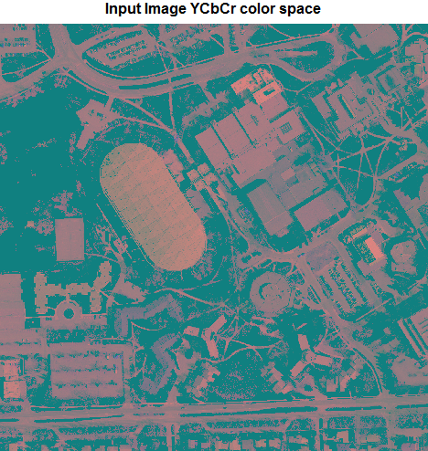 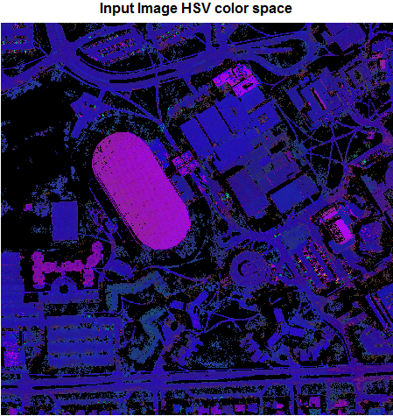

(a) Image in $YCbCr$ Color Space (b) Image in $HSV$ Color Space

Figure : Input Image in Two Different color Spaces

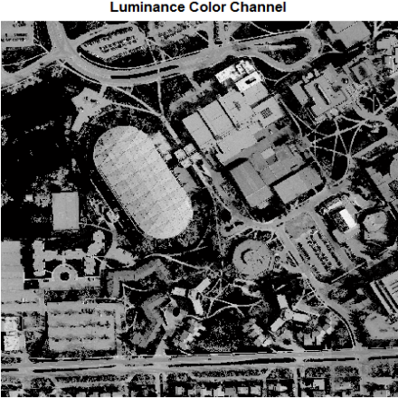 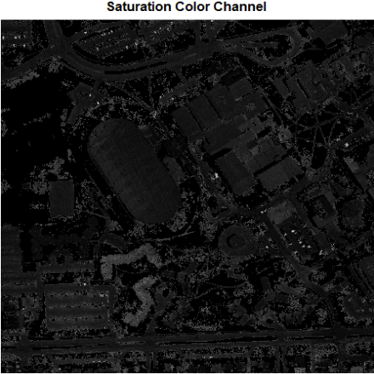 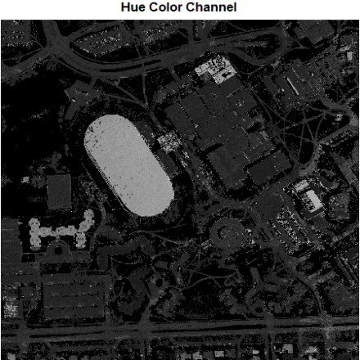

a) Luminance (b) Saturation (c) Hue

Figure : Color Channels Used for Sandy Area Detection

Equation 11 shows the mathematical model for detecting sandy area by applying a global thresholding on the three color channels where $SA$ represents sandy area candidates, $L$ luminance, $S$ saturation, and $H$ hue color channels.

|  |  |
| --- | --- |
|  | () |

Figure 10(a) shows the image of sandy Candidates and Figure 10(b) shows the RGB image of sandy areas. In sandy areas image there are some building pixels identified as sandy candidates. These candidates are pre-classified as buildings (wavelet-LIDAR output), so it has to be removed from sandy area candidates. Figure 10(c) shows sandy area candidates after building removal and Figure 10(d) shows the resultant RGB sandy areas image.

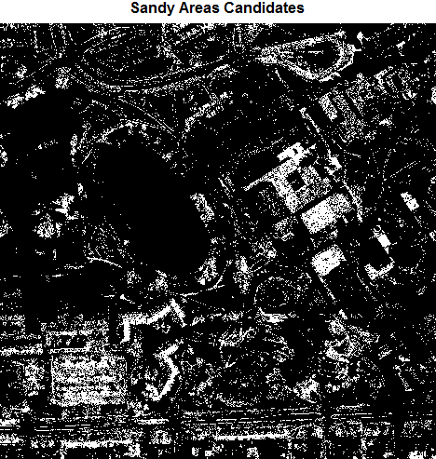 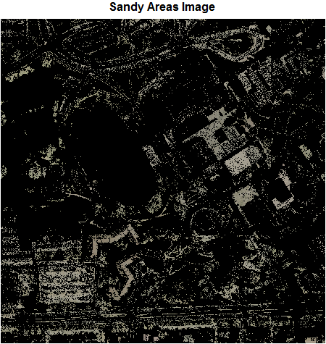

(a) Sandy Area Candidates (b) RGB Sandy Areas

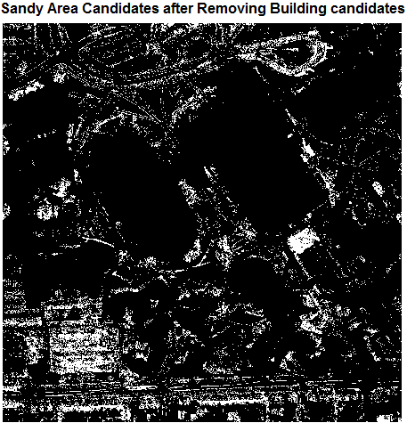 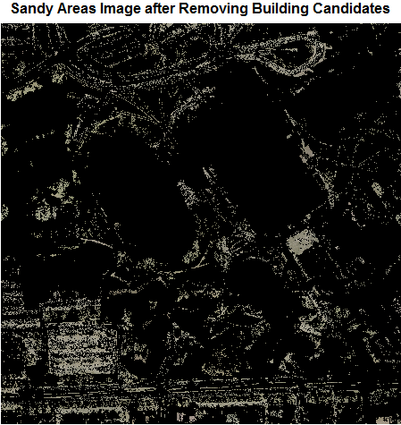

(c) After Removing Building Candidates (d) Resulting RGB Sandy Areas

Figure : Sandy Areas Identification

# road candidates

Road candidates can be identified after removing vegetation, shadows, buildings, and sandy areas from the original RGB image Figure 4(a). Figure 11(a) shows road candidates and Figure 11(b) shows the resulting RGB road image after the application of the combined filtering statistical wavelet multiresolution analysis algorithm.

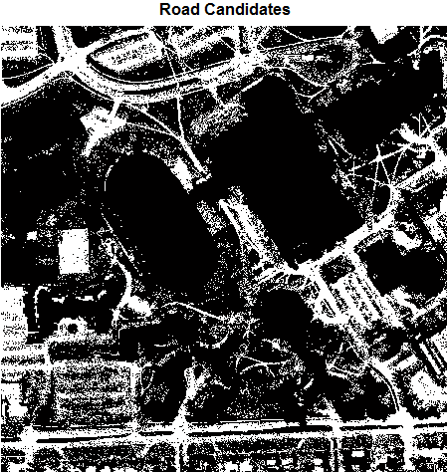 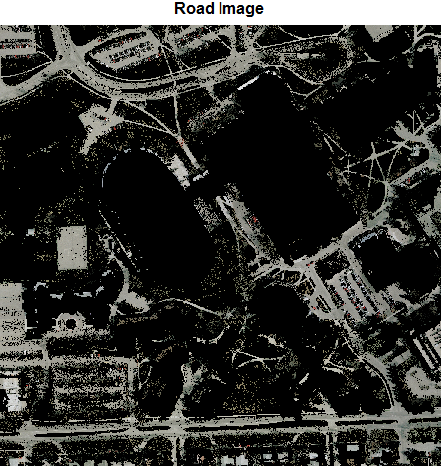

(a) Road Candidates (b) RGB Road Image

Figure : Road Identification

# final urban area classification

After the identification all features from input RGB image using the combined filtering statistical wavelet multiresolution analysis, each feature pixels is segmented as one segment. Figure 12 shows the segmentation results for the input RGB image.

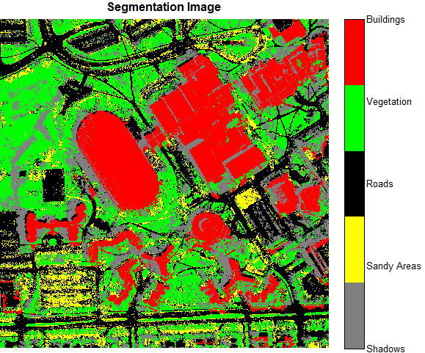

Figure : Segmentation Results for Input RGB Image

Input RGB image is a part of urban area, so the possibility of existing sandy areas is low. It is cleared from the segmented image, some road pixels is segmented as sandy areas. The most important features in urban areas are building, vegetation, and roads, so the sandy area candidates are re-classified as road candidates. The shadows cannot be neglected because there is high possibility to exist and it depends on direction of the light source, so it should be included in the classification of urban areas. Figure 13 shows the final classification for input RGB image for the tested urban area data.

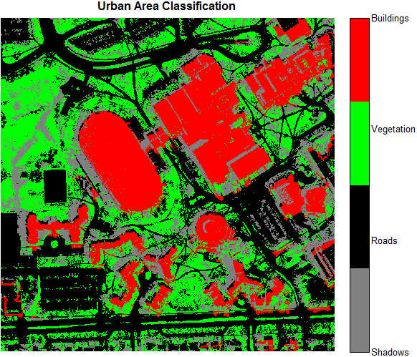

Figure : Final Classification of Urban Area

# Summary and conclusions

Although RGB image contain high descriptive information for ground and non-ground features, it is not enough to clearly classify all features. LIDAR data gives an important spatial information that helps in distinguishing between ground and non-ground features sharing same texture properties (roads and buildings). The combination of these two types of data with the application of the proposed combined filtering statistical wavelet multiresolution analysis introduced an efficient algorithm for urban feature classification. After the separation of buildings by applying wavelet multiresolution analysis to LIDAR data, the output is fused with the responding RGB to remove the building pixels from it. This is followed by the application of Ostu thresholding and color transformation to separate vegetation and shadows and Sandy area, leading to the full separation of the different roads and high ways.

The proposed feature combined filtering statistical wavelet multiresolution analysis classification technique is automatic and should efficiency in feature classification when applying in urban area.

# references

Al-Durgham, M. (2007) *Alternative methodologies for the quality control of LiDAR systems*, M.Sc., University of Calgary (Canada), Canada

Bong, D. B. L., K. C. Lai, and A. Joseph (2009) "Automatic Road Network Recognition and Extraction for Urban Planning," *Proceedings of World Academy of Science: Engineering & Technology*, vol 53, pp. 209-215

Boyer, K. L., and C. Unsalan (2005) "A system to detect houses and residential street networks in multispectral satellite images," *Computer Vision and Image Understanding*, vol 98, no 3, pp. 423-461

Falkowski, M. J., A. M. S. Smith, A. T. Hudak, P. E. Gessler, L. A. Vierling, and N. L. Crookston (2006) "Automated estimation of individual conifer tree height and crown diameter via two-dimensional spatial wavelet analysis of lidar data," *Canadian Journal of Remote Sensing*, vol 32, no 2, Apr, pp. 153-161

Ghanma, M. (2006) *Integration of photogrammetry and LIDAR*, Ph.D., University of Calgary (Canada), Canada

Gonzalez, R. C., and R. E. Woods (2002) *Digital image processing*, Prentice Hall, Upper Saddle River (NJ)

Gonzalez, R. C., R. E. Woods, and S. L. Eddins (2004) *Digital Image processing using MATLAB*, Pearson Prentice Hall, Upper Saddle River, N.J.

Keller, W. (2004) *Wavelets in geodesy and geodynamics*, Walter de Gruyter, Berlin; w York

Kim, C., A. Habib, and P. Mrsitik (2007) "New Approach for Planar Patch Segmentation using Airborne Laser Data," *ASPRS—American Society for Photogrammetry and Remote Sensing, Annual Conference*, May 7-11, 2007, Tampa, Florida

Nardinocchi, C., M. Scaioni, and G. Forlani (2001) "Building extraction from LIDAR data," Piscataway, NJ, USA, pp. 79-84, IEEE

Otsu, N. (1979) "A threshold selection method from gray-level histograms," *IEEE Transactions on Systems, Man and Cybernetics*, vol 9, no 1, pp. 62-66

Shorter, N., and T. Kasparis (2009) "Automatic Vegetation Identification and Building Detection from a Single Nadir Aerial Image," *Remote Sensing*, vol 1, no 4, pp. 731-757

Sirmacek, B., and C. Unsalan (2008) "Building detection from aerial images using invariant color features and shadow information," in *23rd International Symposium on Computer and Information Sciences, 2008. ISCIS '08.* ,27-29 Oct. 2008,1-5

Song, Y., and J. Shan (2008) "Buiding Extraction from High Resolution Color Imagery Based on Edge Flow Driven Active Contour and JSEG," *Remote Sensing and Spatial Information Sciences*, vol XXXVII, no Part B3a, Beijing, 2008, pp. 185 - 190

Vu, T. T., and M. Tokunaga (2002) "Wavelet-Based Clustering Method to Detect Building in Urban Area from Airborne Laser Scanner Data," In: *MapAsia 2002*, <http://www.gisdevelopment.net/technology/ip/techip009.htm>

Vu, T. T., and M. Tokunaga (2004) "Filtering airborne laser scanner data: A wavelet-based clustering method," *Photogrammetric Engineering and Remote Sensing*, vol 70, no 11, pp. 1267-1274

Wang, C.-K., and P.-H. Hsu (2006) "Building extraction from lidar data using wavelet analysis," *27th Asian Conference on Remote Sensing*, Ulaanbaatar, Mongolia

Zeng, Q. (2008) "Data filtering and feature extraction of urban typical objects from airborne lidar point cloud," *The International Archives of the Photogrammetry, Remote Sensing and Spatial Information Sciences*, vol XXXVII. Part B3b, no B3b, pp. 153-156